SETTING UP APPLICATION ENVIRONMENT DOCKER INSTALLATION

|  |  |
| --- | --- |
| **DATE** | **24 OCT 2022** |
| **TEAM ID** | **PNT2022TMID30749** |
| **PROJECT NAME** | **SKILL AND JOB RECOMMENDER APPLICATION** |
| **TEAM MEMBERS:** | **Bavadharshini Harishni T,**  **Madhumitha A,**  **Madhumitha K, Monisha M**  **M** |

# STEP 1

[***install/***](https://docs.docker.com/desktop/install/windows-install/)

Go the official Docker website: [***https://docs.docker.com/desktop/install/windows-***](https://docs.docker.com/desktop/install/windows-install/)

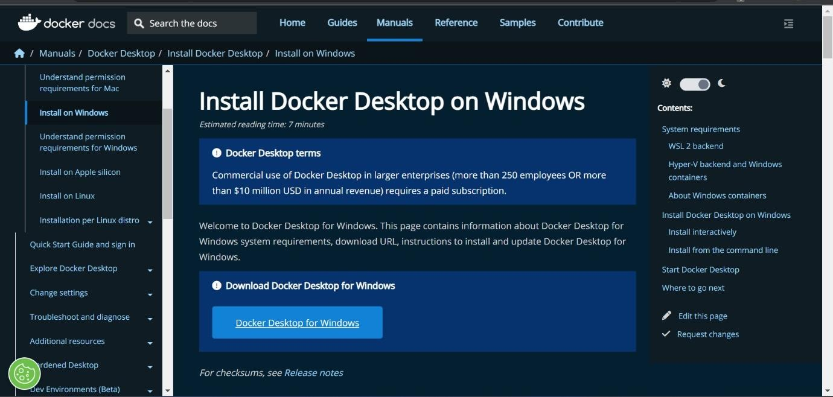

# STEP 2

Click that button (Docker Desktop for Windows) and download will start and it takes few minutes to complete.

# STEP 3

Go to downloads in browser (or) type **ctrl + J**, it will navigate to download page and double-click the particular docker file.

# STEP 4

Now Installation is complete. This icon was added in your desktop. Double-click the icon to start the docker app, you can register and login that app to access those credentials.

# STEP 5

Docker will start correctly, the left bottom side was shown in green color, docker will show the status of docker app working successfully.

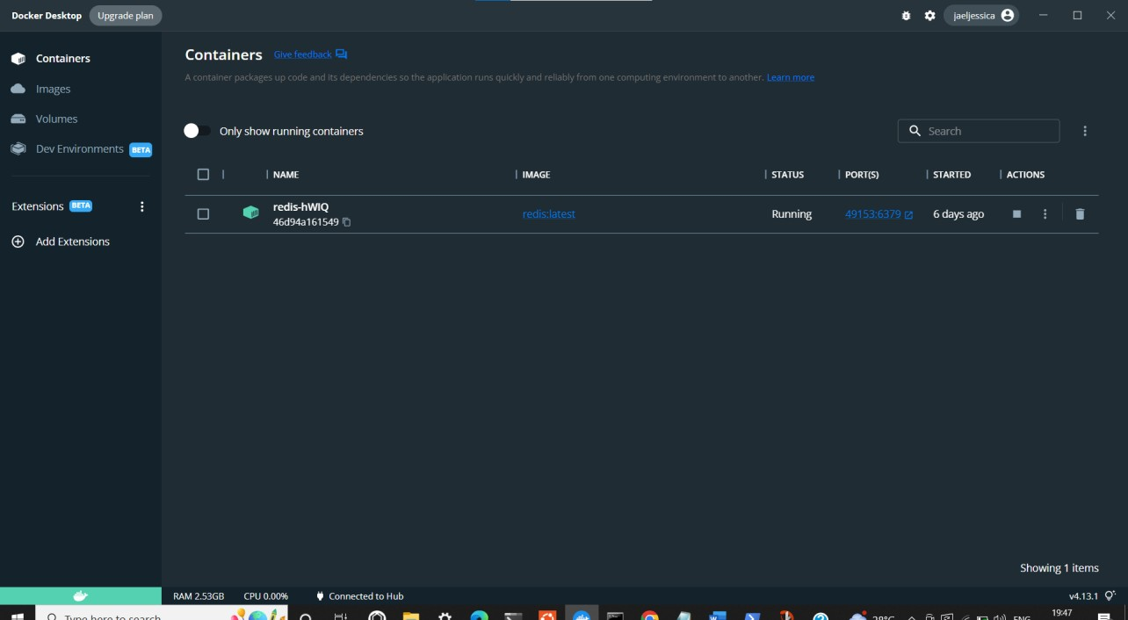

# STEP 6

Finally, the docker is installed successfully.